Case Report - Sheheryar Ali
Holding CNIC: 42301-4238817-9

1. Background of Employment
- Mr. Sheheryar Ali was employed with eSpark Talent as a Shopify Developer from 21st September 2023 until 28th July 2025.
- During his tenure, he was deputed to work with one of our valued clients, eZLO, on professional projects.
- Following internal restructuring at eZLO, his services (along with others) were terminated. Consequently, he was also removed from our internal systems, as his role was directly tied to client engagement.
- Mr. Sheheryar Ali was aware that this was not the first time there had been delays in payments from eZLO, as such delays had occurred previously as well. He had even contacted multiple people of eZLO on multiple occasions to inquire about the status of his dues.

2. Financial Context
- As per contractual agreements, the salaries and duties of employees working for clients like eZLO are dependent upon the timely clearance of invoices by the client.
- In this particular case, eZLO defaulted on its payment obligations, despite repeated reminders from our side.
- This created a backlog of pending employee salaries, including that of Mr. Sheheryar Ali.
- We communicated transparently with him, assuring that the company recognizes its obligation to pay and will clear all dues (including Provident Fund) once the client releases funds.

3. Initial Cooperation from Employee
- Initially, Mr. Sheheryar Ali responded with patience and understanding.
- In direct communication with our CEO, Mr. Huzaifa, he expressed willingness to wait until the client released the payment.
- He further assured the CEO that his brother would arrange financial recovery in the interim, and there was “no cause for worry.”
- During these interactions, Mr. Sheheryar Ali also made repeated references to his brother, claiming that he is associated with the ISI, frequently travels to the United States, and has strong networks both in Pakistan and abroad. He further stated that if there were any legal issues or communication required, his brother could intervene and manage matters due to these connections. In addition, he mentioned that his brother also deals with financial issues, whether related to the recovery of money or other matters.
- At this stage, his conduct appeared cooperative, supportive, and professional.
Evidence: Annexure A – WhatsApp Screenshot shows the conversation between the CEO and Shehryar
4. Sudden Change in Behavior
- Unexpectedly, within a short span of time, Mr. Sheheryar Ali’s attitude shifted drastically.
- He began sending frequent and pressing messages demanding the immediate release of his salary and Provident Fund, despite being previously aware of the pending client payment issue.
- His tone grew increasingly hostile, moving from requests to ultimatums.
- Without warning, he became restless and repeatedly pressured the company to release his pending dues.
Evidence: Annexure B – WhatsApp screenshots of conversations reflect his abrupt shift in behavior.

5. Threats Issued Against the CEO
- Matters escalated when direct threats of violence were made against the CEO of eSpark Talent.
- In a voice note, relayed through his brother on Sheheryar Ali’s instructions to convey to Mr. Huzaifa, it was explicitly stated that if the pending payments were not released, they would abduct the CEO, take him away, and physically harm him until the payment was made. By instigating and directing his brother to deliver such threats, Shehryar not only attempted to intimidate the company but also involved a third party in his misconduct. These threats were made in clear terms with the intention of instilling fear and coercing the company into releasing funds outside of the proper process. This represents a grave violation of professional ethics and crosses into the domain of criminal intimidation and harassment. The threats were not vague or implied; they were explicit, targeted, and personal, aimed at coercing the CEO into making payments outside of agreed procedures.
Evidence: Annexure C – Demonstrates Clear Breach of Conduct
6. Impact on the Company and CEO
- These threats have caused serious psychological distress to our CEO, Mr. Huzaifa
- The company leadership now feels unsafe, and the intimidation has disrupted the smooth functioning of business operations.
- What was initially a financial matter tied to client payment delays has now turned into a security threat to the personal safety of the CEO and, by extension, a risk to the company.

7. Company’s Position
- eSpark Talent has always respected and valued its employees, ensuring that all dues are honored.
- In this matter as well, the company remains committed to releasing Mr. Sheheryar Ali’s payments once funds from eZLO are cleared.
- However, issuing threats of violence, intimidation, and harassment is unacceptable and unlawful.

8. Relief / Action Requested
In view of the above facts, we request immediate legal intervention:
- Filing of a case against Mr. Sheheryar Ali for criminal intimidation, harassment, and threats of violence.
- Provision of protective measures for our CEO, Mr. Huzaifa, against any attempt at physical harm.
- Formal investigation of voice notes, messages, and communication records to establish the threats.
- Appropriate punitive legal action under the law to prevent recurrence of such misconduct.

Annexures
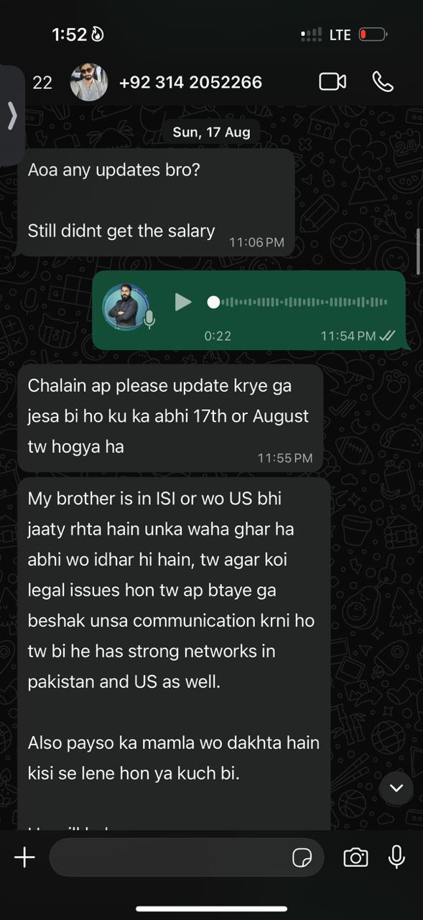
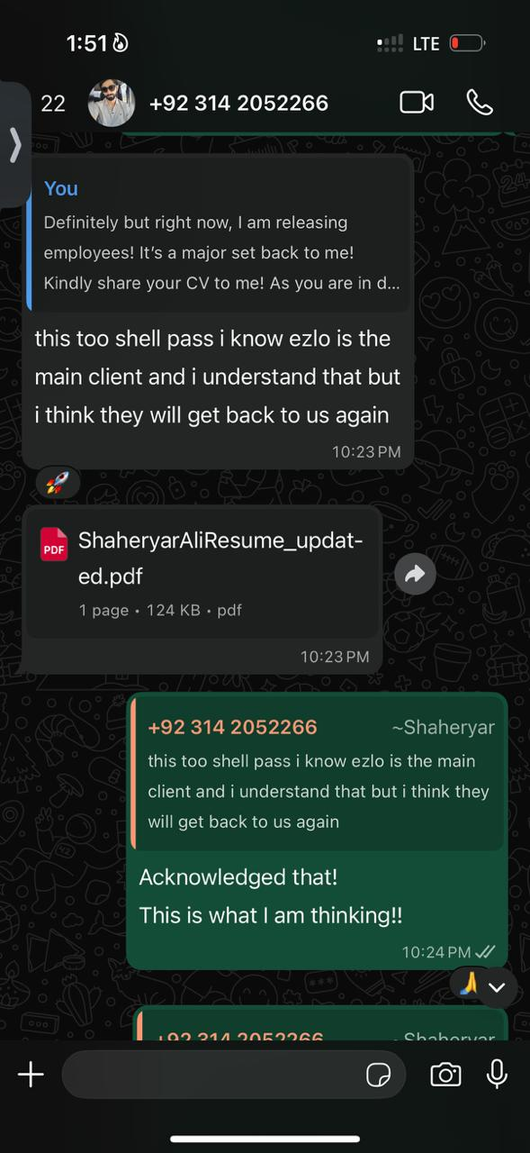
Annexure A:

Annexure B:
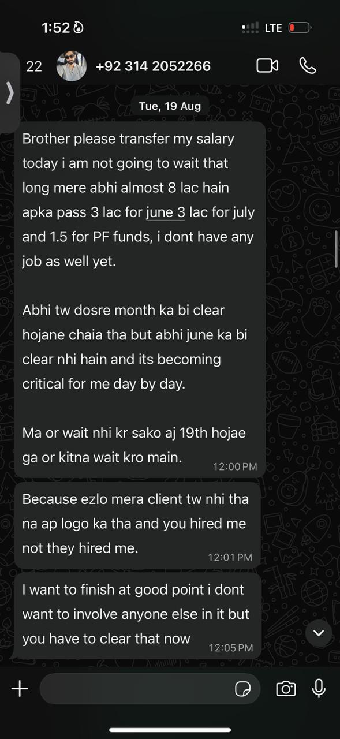
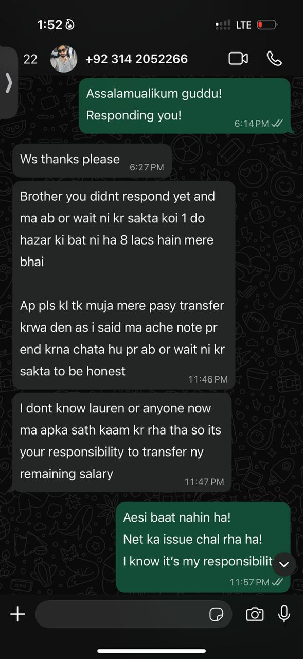

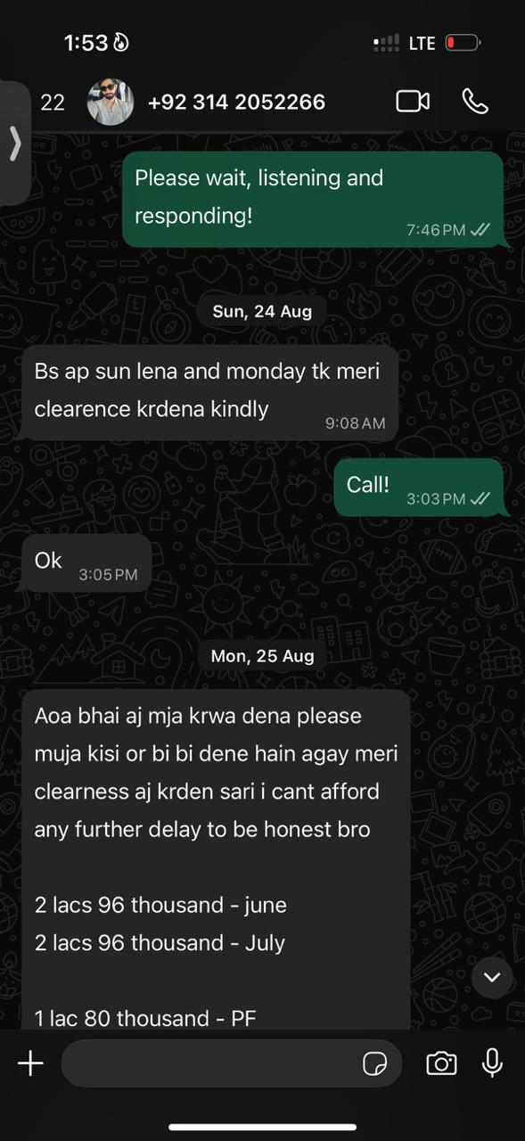
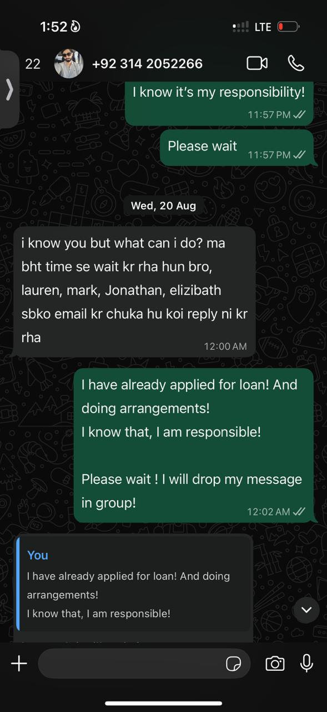
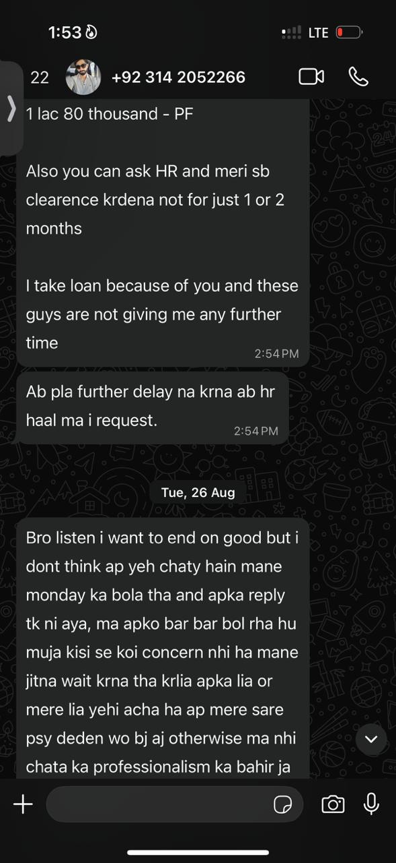
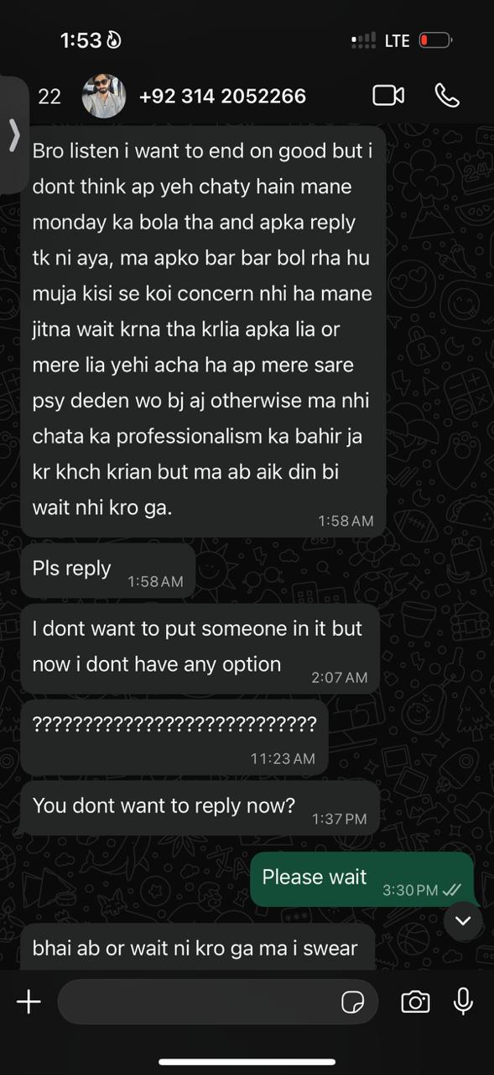
Annexure C:
